Computer Architecture Lab
(EL-2012)
LABORATORY REPORT

Fall 2026

(Lab#2)
Implementation of Combinational Circuits
using Verilog Gate and Dataflow Level Modeling

Student Name: Huzaifa Kashif Roll No: 24I-6501 Section: CE-A

Date performed: 29th August, 2026

MARKS AWARDED: ________ / 10

Signature and date of Instructor: _________________
Lab Instructors: Dr. Nasir Ali Shah, Engr. Fasih Ahmad

______________________________________________________________________________________________________________________________________________________

NATIONAL UNIVERSITY OF COMPUTER AND EMERGING SCIENCES, ISLAMABAD
Prepared by: | Fasih Ahmad |  | Version: 1.0
Verified by: | Dr. Nasir Ali Shah |  | Updated: Fall 2026

Task 1:

Description:
Here we had to make a full adder. I made two separate modules for the half adders one having the output of go into the input of the other, along with the cin. Another final module for the full adder for the final sum and final carry.

Code:
Gate Level:

module ha1(sum,carry,a,b);
input a;
input b;
output sum;
output carry;
xor(sum,a,b);
and(carry,a,b);
endmodule

module ha2(sum,carry,a,b);
input a;
input b;
output sum;
output carry;
xor(sum,a,b);
and(carry,a,b);
endmodule

module fa(SUM,COUT,a,b,cin);
input a; input b; input cin;
output SUM; output COUT;

wire s1;
wire c1;
wire c2;
ha1 half1(s1,c1,a,b);
ha2 half2(SUM,c2,s1,cin);
or (COUT,c1,c2);
endmodule

module testbench();
reg a;
reg b;
reg cin;
wire SUM;
wire COUT;

fa uut(SUM,COUT,a,b,cin);

initial
begin
a=0; b=0; cin=0;
#50 a=0; b=0; cin=1;
#50 a=0; b=1; cin=0;
#50 a=0; b=1; cin=1;
#50 a=1; b=0; cin=0;
#50 a=1; b=0; cin=1;
#50 a=1; b=1; cin=0;
#50 a=1; b=1; cin=1;
end
endmodule

DataFlow Level:

module ha1(sum,carry,a,b);
input a;
input b;
output sum;
output carry;
assign sum = a^b;
assign carry = a & b;
endmodule

module ha2(sum,carry,a,b);
input a;
input b;
output sum;
output carry;
assign sum = a^b;
assign carry = a & b;
endmodule

module fa(SUM,COUT,a,b,cin);
input a; input b; input cin;
output SUM; output COUT;

wire s1;
wire c1;
wire c2;
ha1 half1(s1,c1,a,b);
ha2 half2(SUM,c2,s1,cin);
assign COUT = c1+c2;
endmodule

module testbench();
reg a;
reg b;
reg cin;
wire SUM;
wire COUT;

fa uut(SUM,COUT,a,b,cin);

initial
begin
a=0; b=0; cin=0;
#50 a=0; b=0; cin=1;
#50 a=0; b=1; cin=0;
#50 a=0; b=1; cin=1;
#50 a=1; b=0; cin=0;
#50 a=1; b=0; cin=1;
#50 a=1; b=1; cin=0;
#50 a=1; b=1; cin=1;
end
endmodule

Output:
Gate Level:
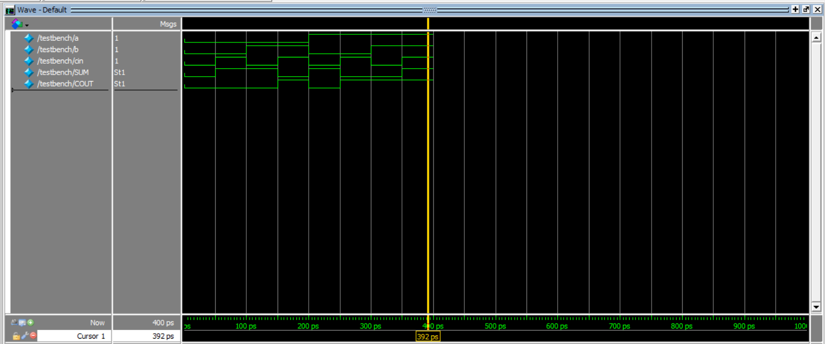

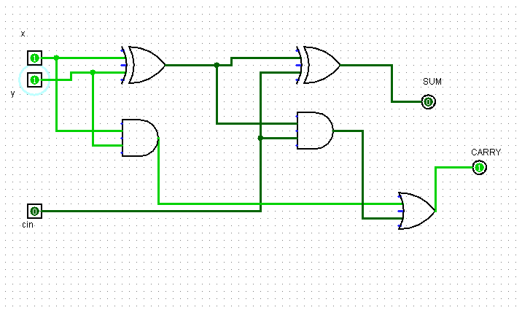

Task 2:

Description:
Here we had to make a 3x8 decoder. Here I made the truth table for the 3x8 decoder and recreated it in Verilog modules.

Code:
Gate Level:

module decode (y0,y1,y2,y3,y4,y5,y6,y7,a,b,c);
input a,b,c;
output y0,y1,y2,y3,y4,y5,y6,y7;

wire nota,notb,notc;

not(nota,a);
not(notb,b);
not(notc,c);

and(y0,nota,notb,notc);
and(y1,nota,notb,c);
and(y2,nota,b,notc);
and(y3,nota,b,c);
and(y4,a,notb,notc);
and(y5,a,notb,c);
and(y6,a,b,notc);
and(y7,a,b,c);
endmodule

module testbenchDecode();
reg a,b,c;
wire y0,y1,y2,y3,y4,y5,y6,y7;

decode uut(y0,y1,y2,y3,y4,y5,y6,y7,a,b,c);

initial
begin
a = 0; b = 0; c = 0;
#50 a = 0; b = 0; c = 1;
#50 a = 0; b = 1; c = 0;
#50 a = 0; b = 1; c = 1;
#50 a = 1; b = 0; c = 0;
#50 a = 1; b = 0; c = 1;
#50 a = 1; b = 1; c = 0;
#50 a = 1; b = 1; c = 1;
end
endmodule

DataFlow Level:

module decode (y0,y1,y2,y3,y4,y5,y6,y7,a,b,c);
input a,b,c;
output y0,y1,y2,y3,y4,y5,y6,y7;

wire nota,notb,notc;

assign nota = ~a;
assign notb = ~b;
assign notc = ~c;

assign y0 = nota & notb & notc;

assign y1 = nota & notb & c;

assign y2 = nota& b &notc;

assign y3 = nota&b&c;

assign y4 = a&notb&notc;

assign y5 = a&notb*c;

assign y6 = a&b&notc;

assign y7 = a&b&c;
endmodule

module testbenchDecode();
reg a,b,c;
wire y0,y1,y2,y3,y4,y5,y6,y7;

decode uut(y0,y1,y2,y3,y4,y5,y6,y7,a,b,c);

initial
begin
a = 0; b = 0; c = 0;
#50 a = 0; b = 0; c = 1;
#50 a = 0; b = 1; c = 0;
#50 a = 0; b = 1; c = 1;
#50 a = 1; b = 0; c = 0;
#50 a = 1; b = 0; c = 1;
#50 a = 1; b = 1; c = 0;
#50 a = 1; b = 1; c = 1;
end
endmodule

Output:
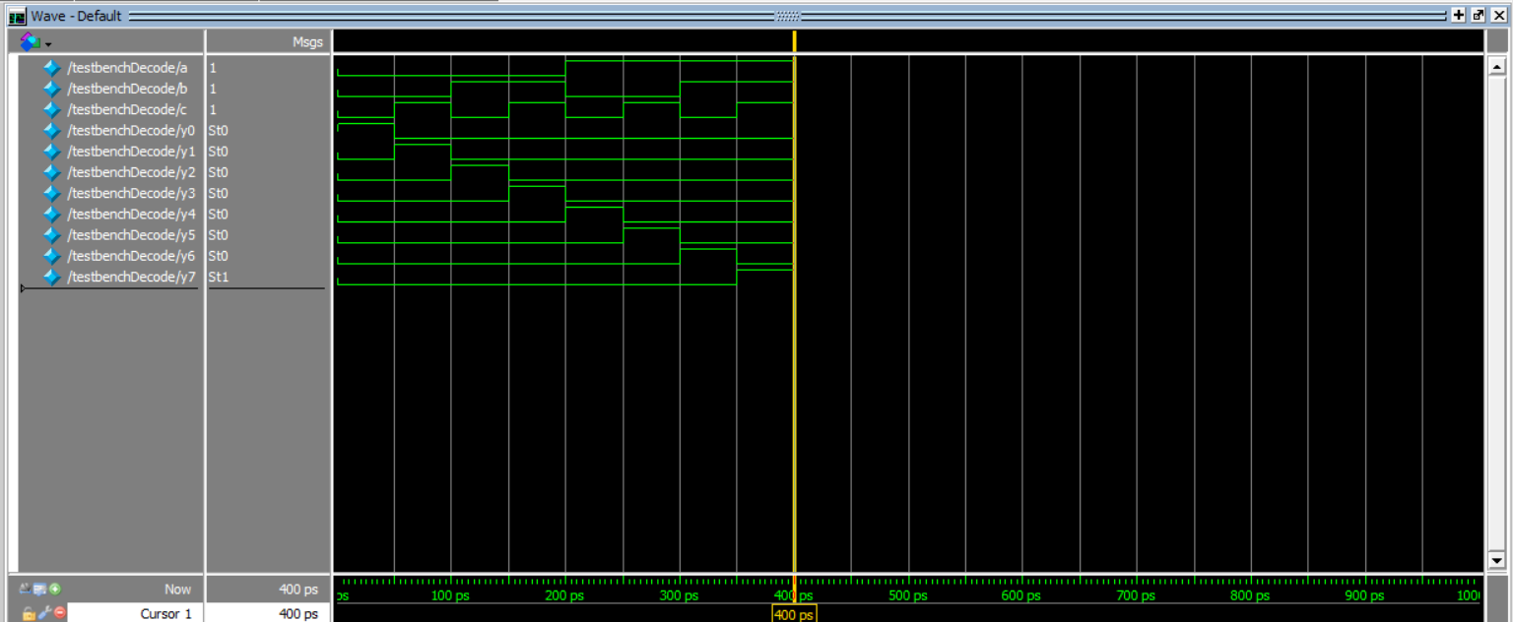

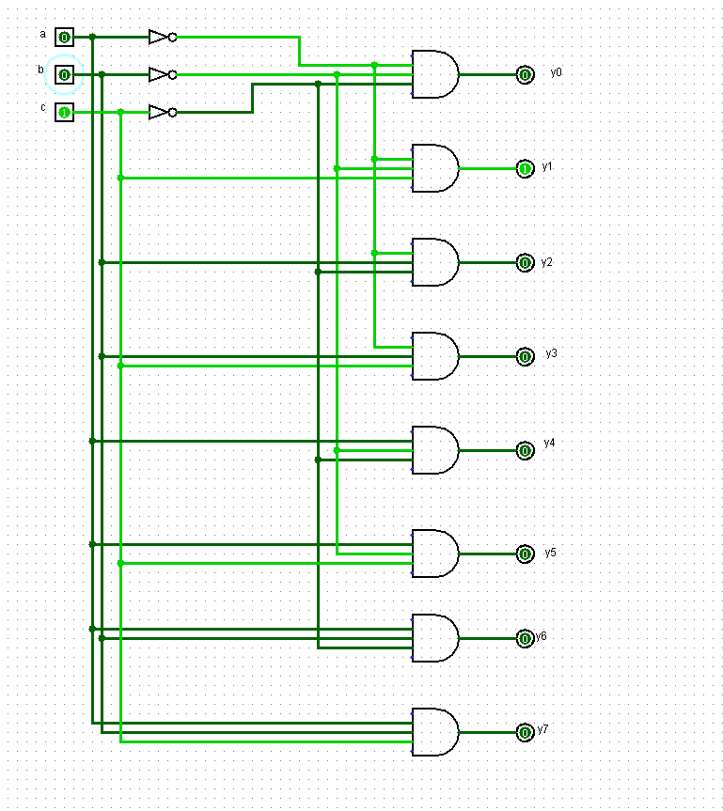

Task 3:

Description:
Here we had to make a 1x8 multiplexer. Here i first created the truth table separately. It uses 3 select lines to choose from the input lines. Here I replicated it into Verilog modules.

Code:
Gate Level:
module multiplex(y0,y1,y2,y3,y4,y5,y6,y7,a,b,c,z);
input a,b,c,y0,y1,y2,y3,y4,y5,y6,y7;
output z;
wire nota,notb,notc;
not(nota,a);
not(notb,b);
not(notc,c);

wire w0,w1,w2,w3,w4,w5,w6,w7;

and(w0,y0,nota,notb,notc);
and(w1,y1,nota,notb,c);
and(w2,y2,nota,b,notc);
and(w3,y3,nota,b,c);
and(w4,y4,a,notb,notc);
and(w5,y5,a,notb,c);
and(w6,y6,a,b,notc);
and(w7,y7,a,b,c);
or(z,w0,w1,w2,w3,w4,w5,w6,w7);

endmodule

module testMult();
reg a,b,c,y0,y1,y2,y3,y4,y5,y6,y7;
wire z;
multiplex uut(y0,y1,y2,y3,y4,y5,y6,y7,a,b,c,z);
initial
begin
y0 = 0;
y1 = 0;
y2 = 1;
y3 = 1;
y4 = 0;
y5 = 0;
y6 = 1;
y7 = 0;
a = 0; b = 0; c = 0;
#50 a = 0; b = 0; c = 1;
#50 a = 0; b = 1; c = 0;
#50 a = 0; b = 1; c = 1;
#50 a = 1; b = 0; c = 0;
#50 a = 1; b = 0; c = 1;
#50 a = 1; b = 1; c = 0;
#50 a = 1; b = 1; c = 1;
end
endmodule

DataFlow Level:

module multiplex(y0,y1,y2,y3,y4,y5,y6,y7,a,b,c,z);
input a,b,c,y0,y1,y2,y3,y4,y5,y6,y7;
output z;
wire nota,notb,notc;
assign nota = ~a;
assign notb = ~b;
assign notc = ~c;

wire w0,w1,w2,w3,w4,w5,w6,w7;

assign w0 = y0&nota&notb&notc;

assign w1 = y1&nota&notb&c;

assign w2 = y2&nota&b&notc;

assign w3 = y3&nota&b&c;

assign w4 = y4&a&notb&notc;

assign w5 = y5&a&notb&c;

assign w6 = y6&a&b&notc;

assign w7= y7&a&b&c;

assign z = w0+w1+w2+w3+w4+w5+w6+w7;

endmodule

module testMult();
reg a,b,c,y0,y1,y2,y3,y4,y5,y6,y7;
wire z;
multiplex uut(y0,y1,y2,y3,y4,y5,y6,y7,a,b,c,z);
initial
begin
y0 = 0;
y1 = 0;
y2 = 1;
y3 = 1;
y4 = 0;
y5 = 0;
y6 = 1;
y7 = 0;
a = 0; b = 0; c = 0;
#50 a = 0; b = 0; c = 1;
#50 a = 0; b = 1; c = 0;
#50 a = 0; b = 1; c = 1;
#50 a = 1; b = 0; c = 0;
#50 a = 1; b = 0; c = 1;
#50 a = 1; b = 1; c = 0;
#50 a = 1; b = 1; c = 1;
end
endmodule

Output:
